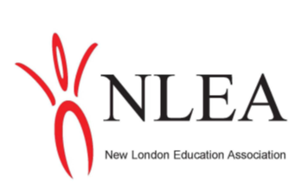
The NLEA is a professional organization of educators that supports children, teachers and public schools. We would like to offer a $710.00 scholarship to a senior going into the field of Education.

Eligibility Guidelines:
- This $710 scholarship will be awarded to a New London graduate going into the field of Education.
- Recipient plans on attending a four-year accredited college/university.
- New London senior submits an essay on: What inspires me to be a teacher (500-750 word essay, typed and double spaced).
- Essays should include a cover page with this information: NLEA Scholarship, student’s full name, home address, phone number and name of parents or legal guardians.
- Include a list of accomplishments or awards received throughout your high school experience.
- Return the essay/list of accomplishments to the New London High School Main Office by April 21st.

